How to connect windows server from windows machine

**www.zippyops.com**

No. 209/210, 1st floor, J.Nager, Panaiyur kuppam main RD, Panaiyur ,  
Chennai 600097

**🖂**[**zippyops@gmail.com**](mailto:zippyops@gmail.com)

**✆+91 7010585768**

We will walk you through the steps to connect windows server from windows machine

Step 1: Click the search bar on the taskbar

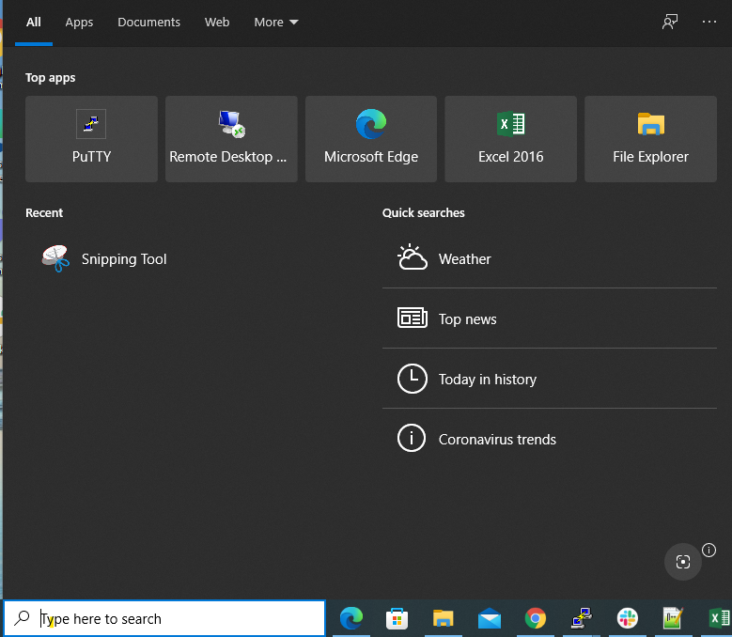

Step 2: Type “msr” (A list of search results appears.)

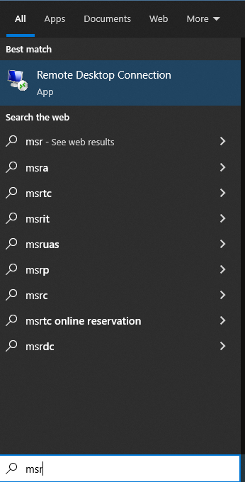

Step 3: Click “Remote Desktop Connection”

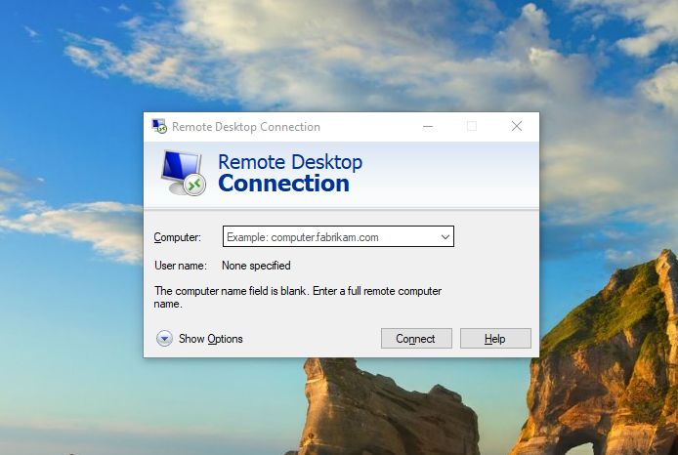

Step 4: In the Remote Desktop Connection window, type the Public IP address

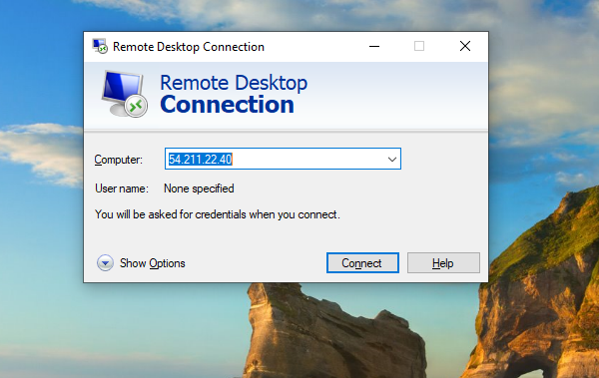

Step 5: Click “Connect” button ,

Windows initiates the remote connection, then you are asked to enter your credentials.

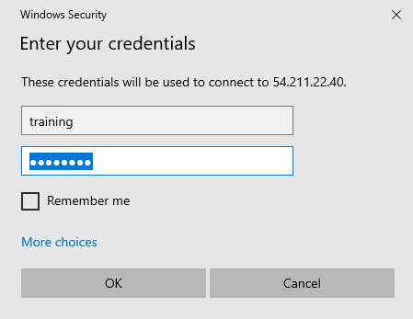

Enter the username and password that you want to use on the computer you’re connecting to, then click “OK”.

Step 6: If you’re informed that the remote computer couldn’t be authenticated due to problems with its security certificate, click “Yes” to connect anyway.

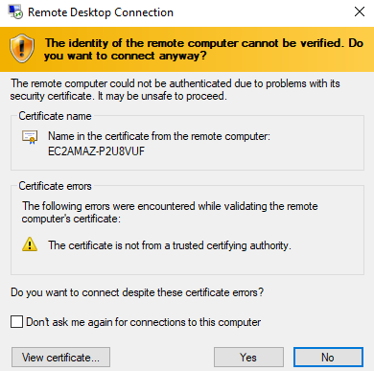

You are now connected to the remote computer and can use it as though it were your local computer.

# Disconnect Remote desktop connection:

When you finish using the Remote Desktop Connection, close the app by clicking the x button on the top of the window, then clicking “OK”.

The remote session is disconnected.